ENGR421 – HW2 REPORT

BERK BAHADIR BAHCETEPE

0071533

For this homework, I started with classifying the data. I took the assigned the first 30000 data points to x-train and the remaining 5000 to x-test. After, I calculated the sample deviations, means and class priors using the equations in Fig.1, Fig.2 and Fig3. respectively. After that, I tried to calculate the gscore of each class in order to select the greatest one and determine the y-predicted for each data point using the formula in Fig.4.

Even though the output of the confusion matrix is different from the required one, the results were more accurate than the one given us by the professor. In my gscore, for each data point, I calculated the gscore of each feature of the input and summed and did this process for each class.

After realizing that my confusion matrix is similar but not exactly the same with the required one, I contacted with the professor and tried so many different algorithms. However, every algorithm I tried on my computer destroyed not only the battery of my computer but also the memory of it. Every time I tried new algorithms that I think it is the accurate one, the Jupiter notebook could not calculate it, it did not give any errors, but I stuck every time I run my code. After I realized that my computer became slower and started to make some weird noises a couple of time, I stopped trying my new algorithms on the data points. I would be so glad if you understand the situation I was in, I was scared to damage the battery and GPU of my computer, so I left the algorithm like this.

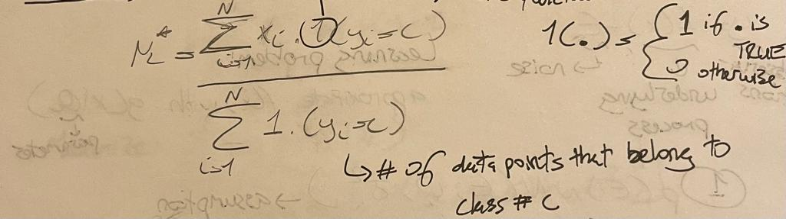

*Fig. 1. The formula of the sample means*

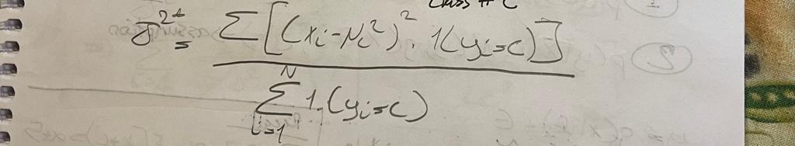

*Fig. 2. The formula of the variance. If we take the square root of the formula above, we obtain the sample deviations*

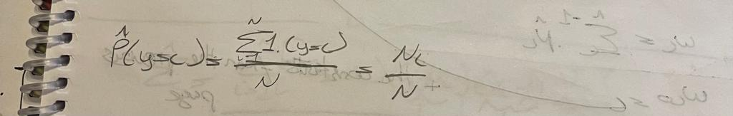

*Fig. 3. The formula of the class priors*

*Fig. 4. The formula of the gscore function*